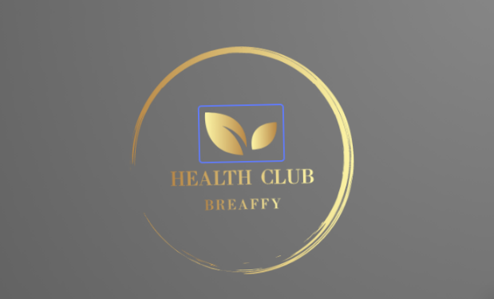

Safeguarding statement

We, The Breaffy Club & Spa are committed to providing a safe environment and experience where the welfare of the child/young person is paramount. All staff who work with children/young people are trained in the relevant areas of child protection and the management of The Breaffy Club and Spa has developed procedures and policies to ensure the welfare of the child is upheld and staff members are fully aware of their roles and responsibilities.
We have a full safeguarding policy and procedures document that outlines procedures and reduce risk and safeguard children including;
- Management of allegations against staff
- Recruitment of staff suitable to work with children
- Reporting of child abuse and welfare concerns to the child and family agency
- Provision of child protection information, instruction and training to staff
- List of qualified persons
- Appointment of relevant person

Shauna Oconnor
Manager
The Spa at Breaffy ~ Health Club Breaffy ~ Blossom at Breaffy

